B.H. COLLEGE
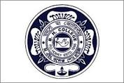
HOWLY:: BARPETA::ASSAM
DEPARTMENT: Education | DATE: 01-10-2023
No. of Students/Participants | 52
Title of the Programme
Collaboration programme between Education department and NCC, B.H. College, Howly
Name of the In-Charge
Dr. Shahjahan Ali, NCC Officer, B.H. College, Howly

Theme- One Hour, One Earth
Description of the Programme
The department of Education in collaboration with NCC,B.H.College and 10th A.P. battalion ,Howly organized a Swachh bharat Abhiyan programme (one hour ,one earth) at Moutupuri 30 badded Hospital. The in-charge of the programme was Lieut. Dr Shahjahan Ali who is also in-charge of NCC unit of the college. Students from both UG and PG took part in the programme.

